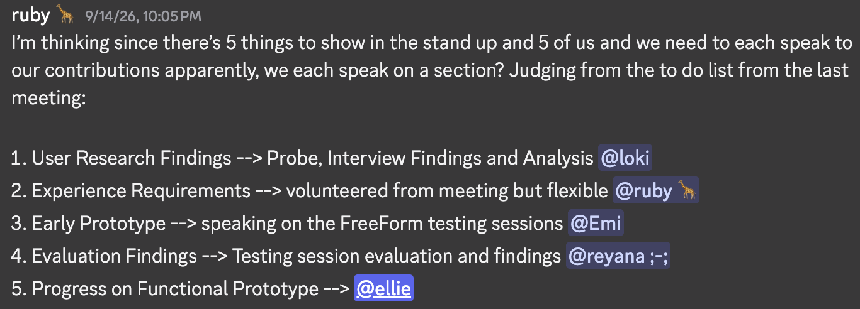
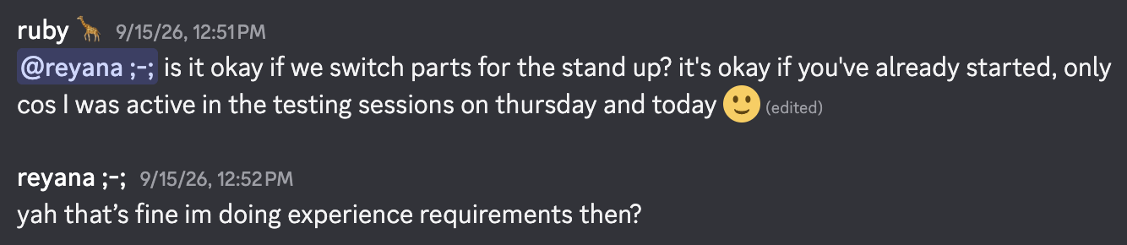

Asked Reyana for her transcripts again for the past 3 weeks.
